**Ideation Phase**

**Brainstorm & Idea Prioritization Template**

|  |  |
| --- | --- |
| Date | 19 October 2022 |
| Team ID | PNT2022TMID04548 |
| Project Name | Inventory Managment System for Retailers |
| Maximum Marks | 4 Marks |

**Brainstorm & Idea Prioritization Template:**

**Team Gathering, Collaboration and the Problem Statement**

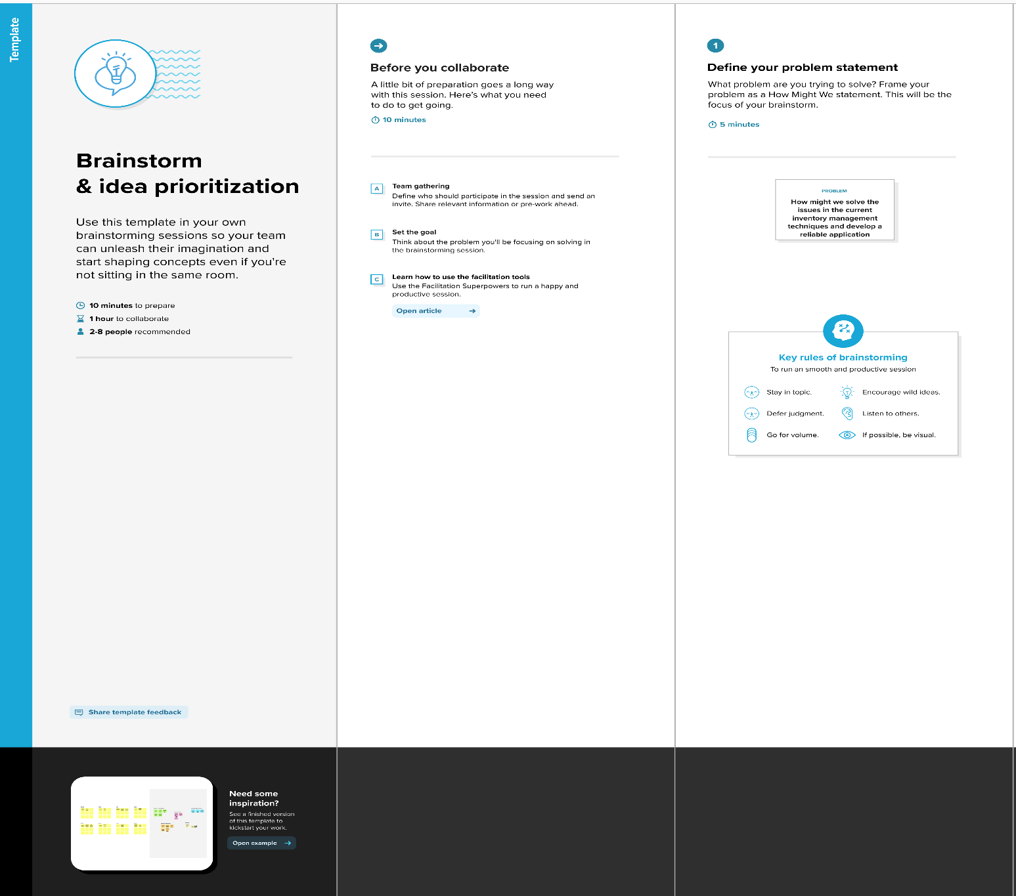

**Brainstorm, Idea Listing and Grouping**

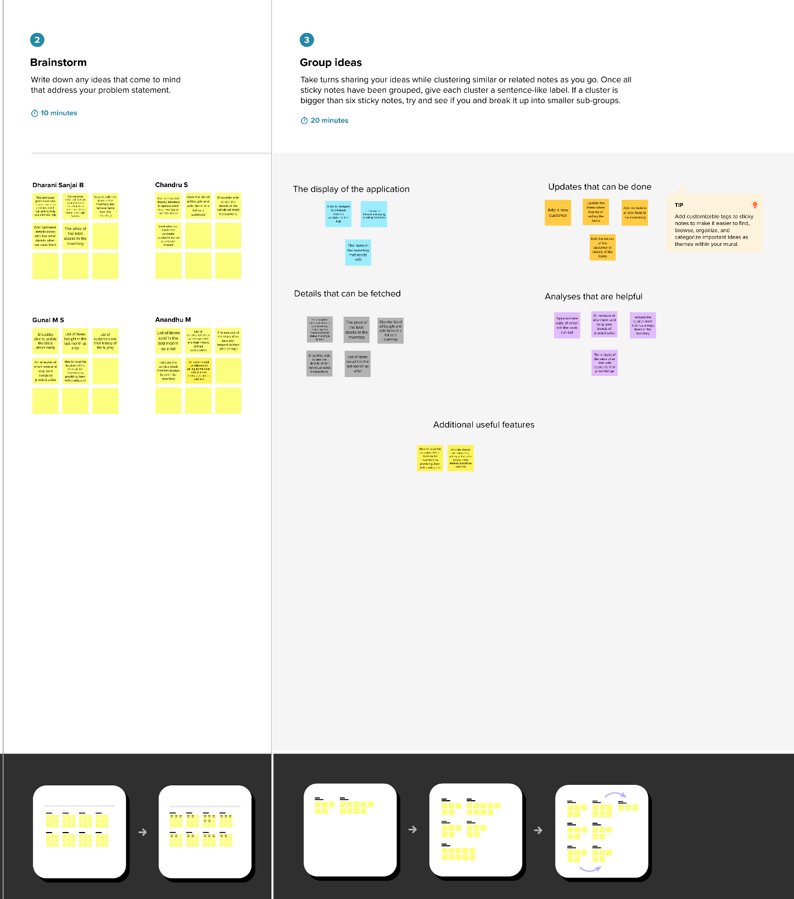

**Idea Prioritization**

